Name: Pranali Sonawane
Subject: MCSA
Date: 16-01-2026
Lab 26: Active Directory Sites and Services and Active Directory Domains and Trust

Server 1:
Active Directory Sites and Services Sites create site Such as Pune, Mumbai, Delhi, Chennai
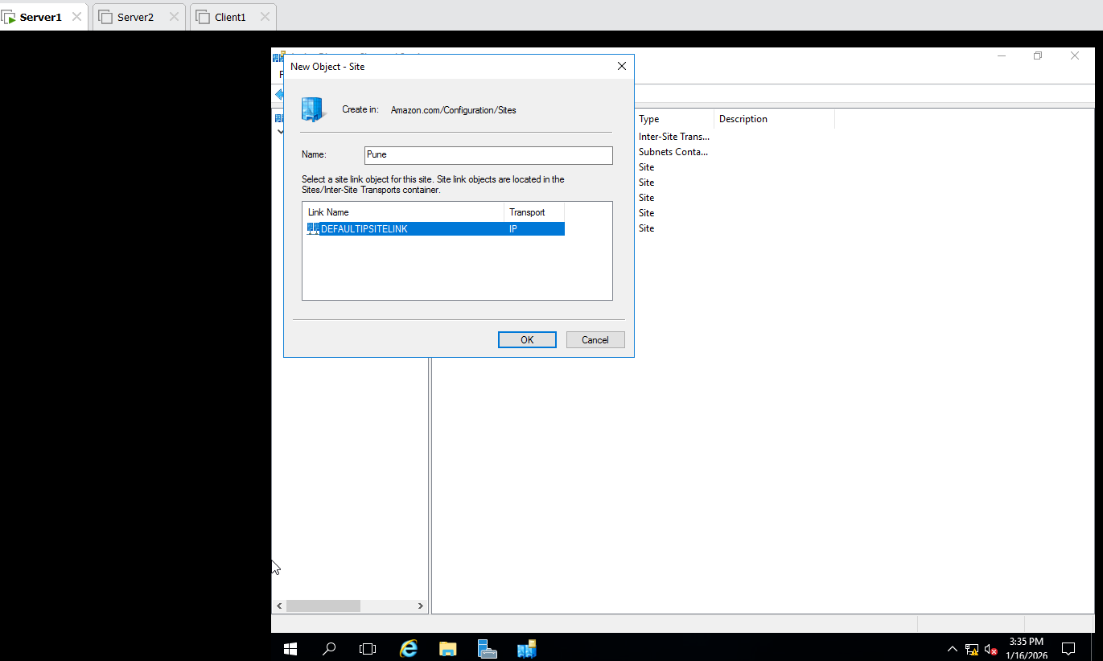
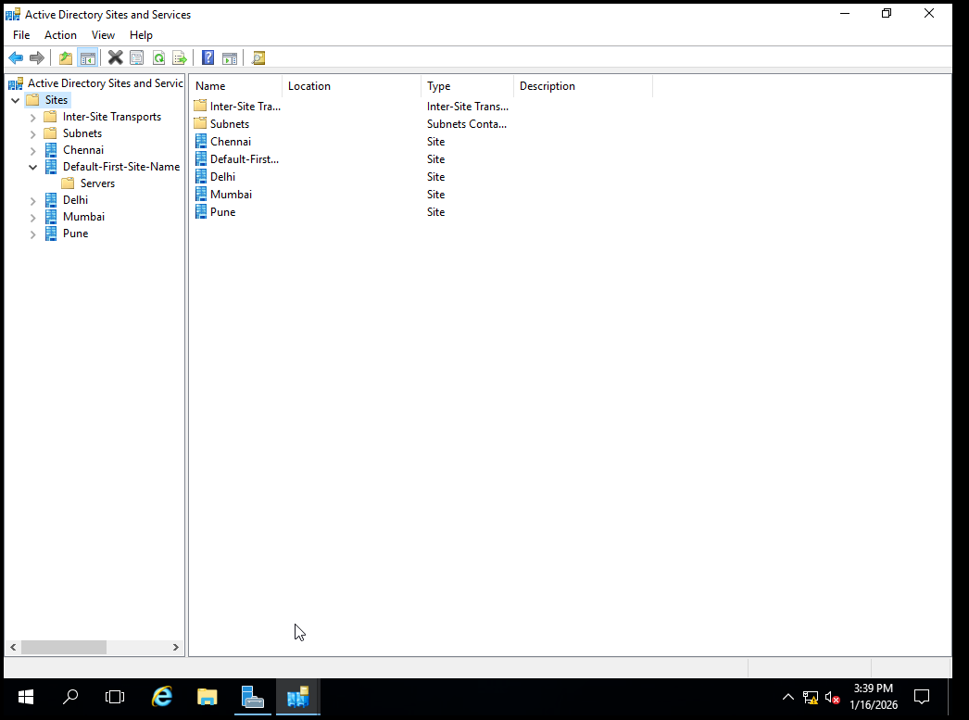
In Pune Site Move Server 1
In Mumbai Site Move Server 2
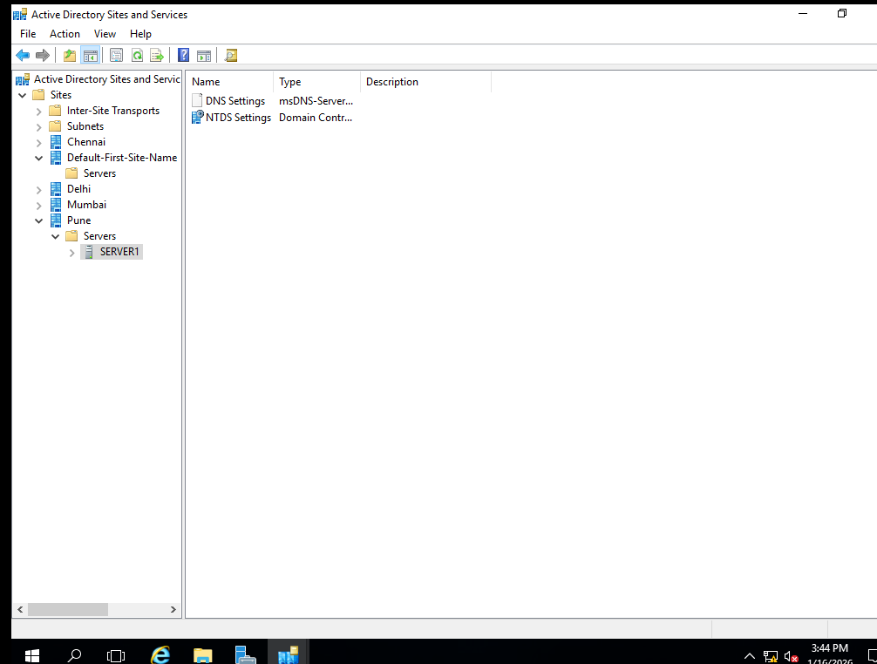

Server 1 :
- Group Policy Management Group Policy Objects New GPO Give Name : Punesites
- In Pune Site Link on Existing GPO Select Punesite

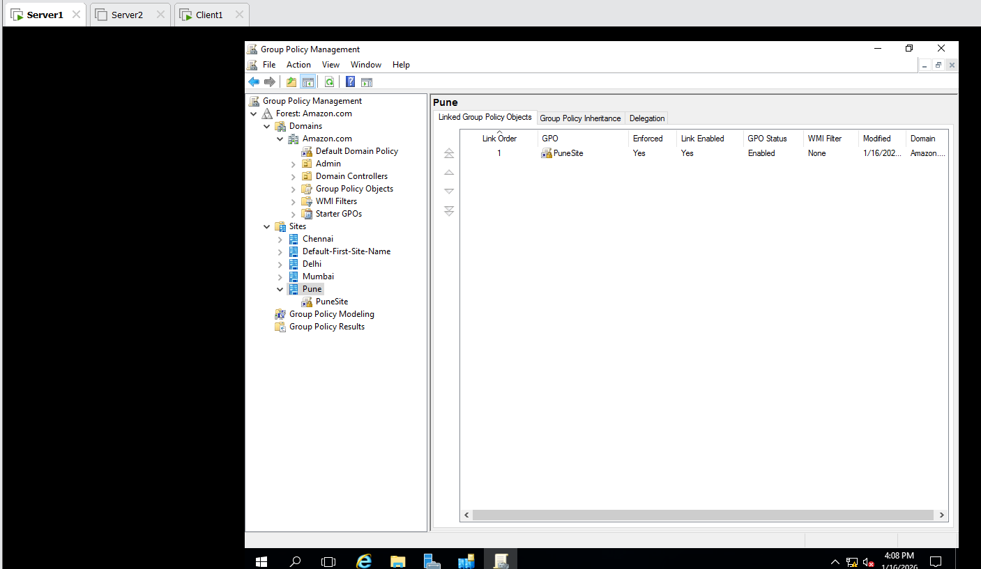

Group Policy Management sites Punesite Right Click on Edit Remove Run Menu From Start Menu
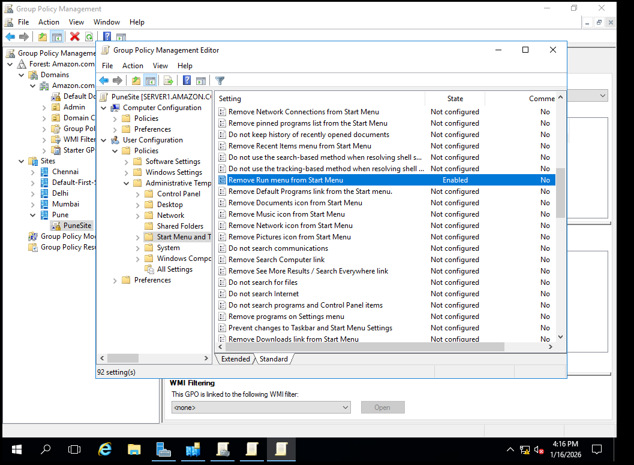
Group Policy Management Amazon Default Domain Policy Right Click on Edit Remove Documents icon From Start Menu
